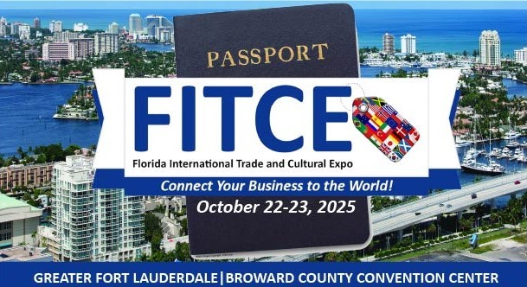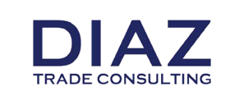

BRITISH TRADE MISSION

# FLORIDA, USA

# 21st – 23rd October 2025

FORT LAUDERDALE, FLORIDA USA

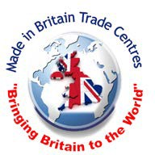

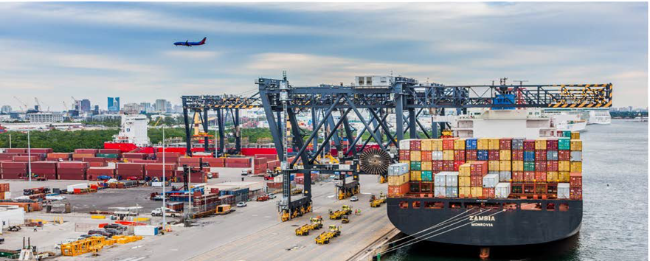

Greetings,

On behalf of the Broward County Board of County Commissioners and Office of Economic and Small Business Development (OESBD), it is an honor to invite you as a member of the British trade mission to the Special Opening Theme Panel on Artificial Intelligence (AI). This is to be held at the 10th Anniversary of the Florida International Trade and Cultural Expo (FITCE) on Wednesday, October 22nd, and Thursday, October 23rd, 2025, at the Greater Fort Lauderdale ꟾ Broward County Convention Center in Fort Lauderdale, Florida. Our AI Panel will be hosted on October 23rd at 8:30AM.

**FITCE 2025 VISION**: To welcome worldwide government and business leaders for a unique opportunity to engage in dialogues and connectivity with the purpose to expand global sales, attract investment opportunities, promote local and international cultural diversity inclusive of tourism, and empower citizens around the world through global trade and economic development while providing tools and resources to the business community:

* Attract more than 2,000 attendees including local and international government dignitaries and key business representatives from over 70 countries
* Recap the origin and celebrate the exponential growth during its 10-year history
* Highlight the economic impact of FITCE across local to international markets and indicators
* Highlight this year’s special conference themes: Artificial Intelligence (AI) and Global Procurement

**FITCE 2025 ACTIVITIES:**

* **Panel Discussions and Seminars**: President’s E-Award Winning “11 Steps to Exporting: A Roadmap to Your Exporting Success!,” “How to Import into the United States,” and more.
* **Doing Business with the World**: Export and investment opportunity presentations by foreign government officials, ambassadors, consuls general, trade commissioners and/or leaders of bi-national chambers of commerce.
* **Speed Matchmaking with Country Representatives**: Meet one-on-one with country representatives including governmental officials, ambassadors, consuls general, trade commissioners and/or leaders of bi-national chambers of commerce.
* **The World Expo Marketplace:** Visit and network with local and international exhibitors representing a phenomenal range of international goods and services or stroll through country pavilions featuring in-depth regional highlights and economic development opportunities.
* **American & International Large Buyers Panel featuring a Meet & Greet:** Learn about the purchasing process of large institutions and build relationships with buyers serious about securing a wide range of goods and services.
* **Networking Receptions & Cultural Experiences hosted by Sustainable Agro Fashion & Tech Week (SAFT):** Immerse yourself in the world of sustainable fashion and experience unprecedented access to tomorrow’s best designers while enjoying cultural performances from around the world and peer networking as well as savoring internationally inspired lite refreshments.

Conference Dates: 22-23 October 2025

​ Conference Location:

Greater Fort Lauderdale | Broward County Convention Center

1950 Eisenhower Blvd., Fort Lauderdale, Florida 33316

United States of America

Registration Deadline: 22 September, 2025

Travel Information:

Official Hotel Information: OMNI Fort Lauderdale

Conference room rates starting at $199/night (taxes not included) are available only until September 17, 2025 (limited availability).

​To coordinate your visit, learn more about FITCE, or to share a brief video of your FITCE experience and resulting economic developments, contact: **Paola Isaac Baraya**, FITCE Event Director and International Chief Economic Development Officer for Trade & Protocol, Broward County Office of Economic and Small Business Development (OESBD) via phone at 954-357-7894 or email [pisaac@broward.org](mailto:pisaac@broward.org)

Thank you for your consideration to participate in Florida’s #1 international trade and cultural expo hosted by a government entity. See you at #FITCE2025!

Sincerely,



Beam Furr

Broward County Mayor

**BRITISH TRADE MISSION PACKAGE (REGISTRATION FEE: £250 PER PERSON) INCLUDES**

• Complimentary 6-foot exhibit table to highlight your business

• Complimentary admission to **FITCE Expo 2025**

• *Travel, lodging, transportation & electricity for table not included.

Please confirm your participation by **Tuesday, 16th September** on the Made In Britain Trade Centre website (FITCE 2025): [www.tradewithbritain.com](http://www.tradewithbritain.com)

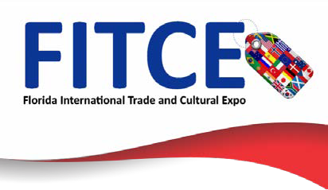

##### ABOUT THE SOUTH FLORIDA REGION

* One of the top locations in the United States for entrepreneurial activity with the most sophisticated and diverse international infrastructure in the world with 70 Consulates and 25 Foreign Trade Offices.
* Business Friendly, low tax environment – individuals pay no state or local personal income taxes; this allows for added incentives when recruiting executives and professionals.
* Streamlined development review and permitting process for new businesses.
* Home of Port Everglades, the leading #1 Port container by export revenue in Florida and 18th busiest Port in the USA as well as 3RD large cruise port in the world (a FITCE partner) www.porteverglades.net.
* A multilingual workforce with approximately 60% of the population in the prime working age group with a deep and diversified pool of talent.
* Home to over 200 corporate headquarters including: American Airlines, American Express, AutoNation, Citrix, DHL, Embraer, Hotwire Communications, Microsoft Latin America, Office Depot, Sony Latin America and UPS just to name a few

**DON’T MISS THIS GREAT OPPORTUNITY TO DO BUSINESS WITH THE WORLD!**

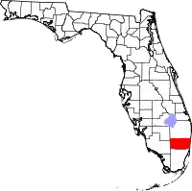

**FORT LAUDERDALE AND BROWARD COUNTY**

**ECONOMIC OUTLOOK OVERVIEW**

**WELCOME TO GREATER FORT LAUDERDALE, SOUTH FLORIDA**

**(Gateway to Latin America and the Caribbean)**

Long known as an international tourist destination, Greater Fort Lauderdale is now the heart of a robust, economic high-growth region. As the geographic centre of the Miami-Fort Lauderdale-West Palm Beach Metropolitan Statistical Area (MSA), Greater Fort Lauderdale has everything you need to succeed - diversified workforce; large market with disposable income; easy access to national/international markets; world class educational options; business friendly government; and outstanding lifestyle. In addition, any area can be designated as a foreign trade zone (FTZ) offering tax, tariff and import advantages.

|  |  |
| --- | --- |
| ***Fort Lauderdale*** | **Southeast Florida (MSA)** |
| **Population 178,752** | **Population 6.8 million - 8th largest in the USA** |
| **Retail/Restaurant Sales $ 6.1 billion** | **Retail/Restaurant Sales $ 106.3 billion** |
|  | |
| **Civilian Workforce 84,369 - 62.5 % white collar,**  **6.5 % blue collar, 21.1 % service** | **Civilian Workforce 3.0 million - 61.1 % white collar,**  **17.3% blue collar, 21.7 % service** |
| **Education - 42.3 % college degree,**  **18.9 % some college** | **Education - 37.7 % college degree,**  **8.7 % some college** |
| **All America City, National Civic League** | **Best Places to Start a Small Business, Biz Journals** |
| **Most Diverse City in Florida, Wallet hub** | **Future Top Cities in US, FDI Magazine** |
|  | |
| **Top 10 Greenest Mid-Sized Cities, MyLife.com** | **2nd Best Place to Start a Business,**  **Kauffman Foundation** |
| **Top 10 Best Downtowns in the USA, Livability.com** | **3rd Least-Costly MSA to do business, KPMG** |
|  | |
| **Top 10 Most Exciting Mid-Sized Cities in America** | **Home to more than 6,000 High Tech firms, Brookings Institute** |
| **Top 10 US Cities for Small Business, Biz2Credit.com** | **Best Places for Global Trade, Global Trade Magazine** |
|  | |
| **Top 10 Best Cities for Millennial Job Seekers**  **in Florida** | **BCPS High Schools Among America’s Best, Newsweek** |
|  |
| **Top 50 US “Tech Talent” Markets, CBRE** | **BEST Hottest Start-Up Hub in US, Kauffman Foundation** |
|  |



## **KEY INDUSTRIES**

There are huge opportunities for British companies to sell consumer products. Broward County has access to 6.8 million people and a diversified multicultural population with an affinity for European and International products.

## **MARINE**

Known as the “International Marine Hub, “Greater Fort Lauderdale’s marine industry leads the State. Fort Lauderdale is the home of the famous Annual Ft Lauderdale International Boat Show and the marine industry encompasses world-class shipyards, manufacturing, wholesale/retail products, brokers, dockage, and every conceivable type of marine service.

The marine industry has an economic impact of $ 8.8 billion in Broward County, generating more than 110,000 jobs. Florida has Sales/Use Tax exemptions that are specific to the Marine Industry.

## **AVIATION & AEROSPACE**

**Why are so many aviation & aerospace companies locating in Greater Fort Lauderdale?**

* Florida ranked 1st for aerospace companies, PricewaterhouseCoopers
* Florida ranked 1st in the nation for aerospace manufacturing
* Florida ranked 2nd in USA for the number of aviation/aerospace companies
* Florida has Sales/Use Tax exemptions specific to the Aviation Industry
* Greater Fort Lauderdale’s aerospace roots is a legacy of its history as an aviation hub
* Embraer and Heiko are headquartered in Broward County

## **CONSUMER PRODUCTS**

There is tremendous perceived value of British brands and goods across the Americas, and SMEs from the world over are moving to these dynamic markets. South Florida’s vibrant multicultural community promises great demand for innovative, quality British merchandise. Not only the home to a vibrant Latin American community, South Florida acts as a shopping *destination and showcase* for millions of Americans that regularly come to South Florida every year.

## **FOOD, DRINK AND HOSPITALITY**

Greater Fort Lauderdale has over 4,100 restaurants, 63 golf courses, 12 shopping malls,

16 museums, 132 nightclubs, and 100 Marinas - hosted 32.5 million visitors who spent

$ 7.6 billion in 2017. Embraced by the Atlantic Ocean, Fort Lauderdale has more than seven miles of beaches and more than 165 miles of inland waterways. Fort Lauderdale has 566 hotel / motel properties with 35,755 rooms and over 11.7 million square feet of shipping and

dining venues.

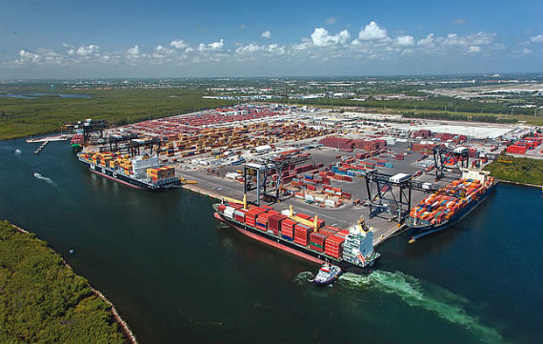

**TECHNOLOGY**

### Why are so many technology companies locating in Greater Fort Lauderdale?

Florida is ranked 3rd in the USA for high-tech companies and exporting of high-tech products

Florida ranked 4th in the USA for technology jobs, Tech America

Ft. Lauderdale among Top 25 US High-Tech Cities, Business Week

Ft. Lauderdale among Top 50 US “Tech Talent Markets, CBRE

Ft. Lauderdale among most wired broadband areas in the USA, Forbes

Home to more than 6,000 high technology firms, Brookings Institute

Headquarters for Microsoft Latin America, Citrix and Magic Leap

**GLOBAL LOGISTICS**

Global Trade magazine named the City of Fort Lauderdale as one of the best cities for Global Trade *- Fort Lauderdale has the facilities and workforce to support global logistics*.

**Port of Everglades:**

Four miles from downtown Fort Lauderdale

#1 in Florida for exports: worldwide trade of $ 24.5 billion

#1 Foreign Trade Zone for Exports - # 18 in the USA

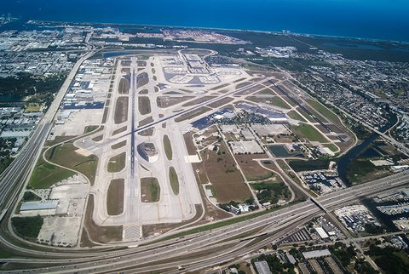

**Fort Lauderdale-Hollywood International Airport (FLL)**:

FLL, four miles from downtown Fort Lauderdale, is ranked 21st in the USA and 7th on the US Airport Affordability Index.

FLL has over 740 flights a day and non- stop service to more than 100 destinations.



**LIFE SCIENCES**

Home to approximately 1,500 bioscience businesses and institutions that employ more than 26,000 people. Greater Fort Lauderdale provides a stimulating and supportive business environment for success in the life sciences industry - medical devices, biomedical, pharmaceutical, clinical research, manufacturing and distribution. The region’s academic institutions and research parks have joined together to form Life Sciences South Florida (LifeSciencesSF.org).

**MANUFACTURING**

## Florida ranks in the top 10 for manufacturing and is home to more than 18,600 manufacturing companies with +321,000 employees and accounts for 72,000 jobs in the Miami and

## Fort Lauderdale MSA.

### Comparative Costs for Manufacturing Companies in Florida versus Other Markets

|  |  |  |  |  |  |  |  |
| --- | --- | --- | --- | --- | --- | --- | --- |
|  | **Florida** | **Alabama** | **Georgia** | **Illinois** | **N.**  **Carolina** | **S.**  **Carolina** | **Texas** |
| **Personal Income Tax (Highest Rate)** | **None** | **5.00 %** | **6.00 %** | **3.75 %** | **5.80 %** | **7.00 %** | **None** |
| **State Tax Climate Rank** | **4** | **28** | **36** | **31** | **16** | **37** | **10** |
| **Manufacturing Average Wage** | **$54,086** | **$50,962** | **$53,980** | **$54,555** | **$53,268** | **$68,868** | **$70,580** |

Mission Cost

Registration Deadline: 22ndSeptember 2025

**Package includes the following:**

* Admission to mission events
* Airport transfers in country when travelling on official mission flights
* Ground transportation to all mission events.

*\*Delegate package does not include any one-on-one appointments*.

**₤350 per person**

**Option 1: Delegate\***

**Package includes the following:**

* One-on-one appointments with pre-screened buyers/distributors
* Admission to mission events
* Airport transfers in country when travelling on official mission flights
* Ground transportation to all mission events.

*\*Initial assessment is done to determine how many meetings can be organised*

**₤250 per person plus**

**₤600 per appointment**

**Option 2: Matchmaking Package * (Discounted for FITCE 2025)**

**Travel Information:**

Official Hotel Information: **OMNI Fort Lauderdale**

**Conference room rates starting at $199/night (taxes not included) are available only until September 17, 2025 (limited availability).**

NOTE:

* Parking is not included. Parking rates to be announced soon.
* Mandatory setup day: Tuesday, October 21, 2025, from 9 AM to 5PM.
* Electricity is not included with the cost of exhibitor registration. Exhibitors have the option to purchase electricity directly from the convention center.
* Visit [**Edlen**](https://ordering.edlen.com/login) to log into Online Ordering​ to complete payment.
* Please note ​early bird pricing for electrical services ends Thursday, October 2, 2025.
* Food / Beverage samples must receive authorization from the Convention Center prior to being distributed. Selling food or beverage consumable on-site is not permitted. Please email bseibert@ftlauderdalecc.com​ to receive authorization application form and further instructions. A certificate of insurance may also be requested.
* For the International Delegation Exhibitor, travel, lodging and transportation are not included. Proof of airfare purchase and hotel reservation may be required for international delegation packages. ​FITCE Official Hotel: OMNI Fort Lauderdale​.​
* Must provide at least one (1) person to staff your exhibit table during Expo hours.

Department for Business and Trade (DBT).

Delegates will also have the opportunity to take advantage of the unparalleled trade facilitation services provided by the British Department for Business and Trade (DBT).both in the UK and Miami, Florida.

The DBT offers a variety of products and services designed to facilitate British exports and foreign direct investment opportunities.

Please refer to <https://www.gov.uk/government/organisations/department-for-business-and-trade> for details of your local DBT offices. Details for all DBT services can be found at <https://www.business.gov.uk/>

The delegation will be limited to British manufacturers, distributors and service companies.

Selection of these firms will be on a first come first-served basis.

Financial support may be available towards your travel costs – please speak to your local Chamber of Commerce or Department for Business and Trade (DBT) office to explore what is available from them, as this varies from region to region.

**Disclaimer:** Made in Britain Trade Centres, the DBT and the Expo organizers will NOT be legally responsible in any way for any losses or damage of any nature (pecuniary or otherwise) that might arise from an introduction to a potential buyer or distributor or for the arrangement of hotel and air flight bookings.



Mission Registration:

Registration can be done online on the website: -

FITCE 2025 - [www.tradewithbritain.com](http://www.tradewithbritain.com/)

Payment details for British Trade Mission:

Made in Britain Trade Centres Limited HSBC BANK

1. Commercial Way WOKING.

Surrey. GU21 6EZ

Sort Code: 40 47 08

Account No. 52483327

Enquiries: Please contact

### Christopher George

#### Chairman/CEO

Made in Britain Trade Centres Ltd

Phone: +44 (0)7964 321 517 (UK)

Email: [chris@tradewithbritain.com](mailto:chris@tradewithbritain.com)

Website: [www.tradewithbritain.com](http://www.tradewithbritain.com/)

**Paola Isaac Baraya, MSc. (FITCE Event Director)**

Economic Development-International Trade

Broward County Office of Economic and Small Business Development Florida USA

Phone: +1 954-357-7894 (USA)

#### Email: [PISAAC@broward.org](mailto:PISAAC@broward.org)

Cancellations

Cancellations must be made in writing to be fully refundable by

**1st October 2025** to:

**Christopher George**: [chris@tradewithbritain.com](mailto:chris@tradewithbritain.com)

Cancellations after that date are non-refundable