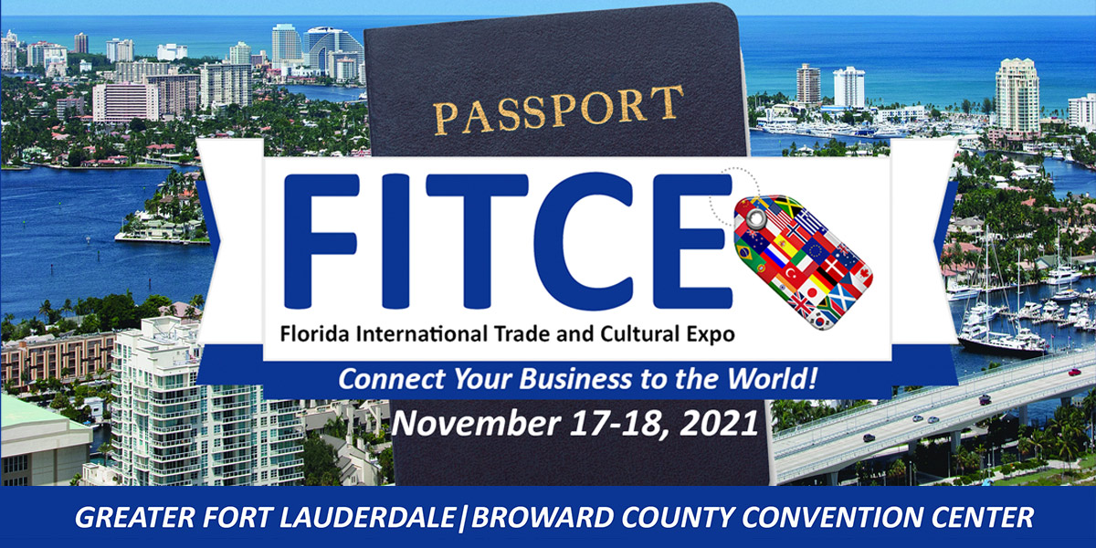
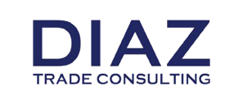

BRITISH TRADE MISSION

FLORIDA, USA

15th – 20th November 2021

FORT LAUDERDALE, FLORIDA USA
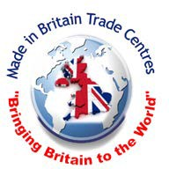

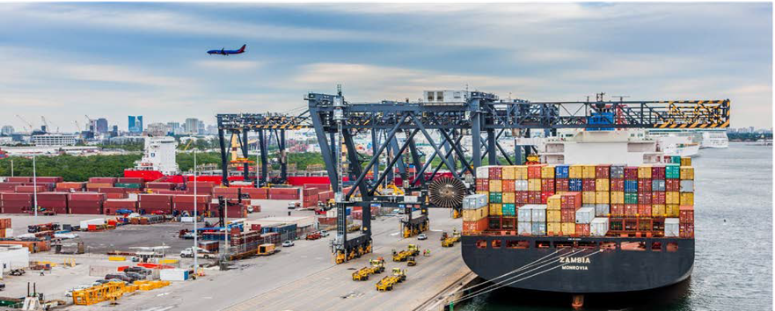
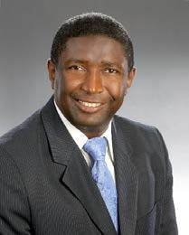
Dear International Trade Delegate,
I am pleased to invite you to participate in the British Trade Mission to Fort Lauderdale, Broward County, Florida scheduled for the week of 15th November 2021 to partake in the International Trade & Cultural Expo 2021 (FITCE) on 17th and 18th November 2021 at the Broward County Convention Center and other programmed business activities.
Broward County, South Florida, is leading the way in the USA economic recovery.
We are getting full traction towards a stronger, more vibrant economy. Our tourism numbers are up, and our international airport and seaport have never been busier. The road ahead looks bright!
In addition to the economic importance of tourism to the State, international trade and culture also contribute greatly to our economy. For 2018, trade through the South Florida region (Miami-Dade, Broward and Palm Beach County) surpassed $ 107.71 billion, the second highest amount on record and the sixth year the total has eclipsed the $100 billion-dollar mark. Our Customs District enjoys a robust trade surplus of $10.78 billion and has more than 60,000 companies registered to export.
One of the goals coming out of the most recent Broward County Commission Strategic Plan Visions and Goals workshop was for Broward County to “Become the center for trade in Florida to the world especially to Latin America and the Caribbean” and host a signature event - the Florida International Trade & Cultural Expo 2021.
British companies are well-positioned to benefit from these opportunities as products and services made in Britain are respected globally for their perceived quality and innovation. The Florida International Trade & Cultural Expo 2021 will provide you with an excellent opportunity to meet buyers and distributors from all over the world and learn more about trade and logistics across the USA, Latin America and the Caribbean and other parts of the world.
I urge you to join the British trade mission to FITCE as we work together to build closer business and trade relations between the State of Florida and the United Kingdom.
Sincerely,
Dale V.C. Holness
Broward County Commissioner (District 9) State of Florida

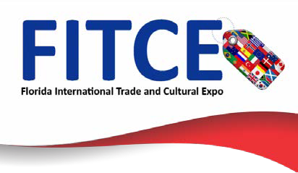

ABOUT THE SOUTH FLORIDA REGION

One of the top locations in the United States for entrepreneurial activity with the most sophisticated and diverse international infrastructure in the world with 70 Consulates and 25 Foreign Trade Offices.

Business friendly low tax environment – individuals pay no State or local personal income taxes; allows for added incentive when recruiting executives and professionals.

Streamlined development review and permitting process for new businesses.

Home of Port Everglades, the leading #1 Container Port by tonnage for exports in Florida and 18th busiest Port in the USA as well as being the 3rd largest cruise port in the world (a FITCE partner)

A multilingual workforce with approximately 60% of the population in the prime working ages offers a deep and diversified pool of talent.

Home to over 200 corporate headquarters including: Alcatel‐‐Lucent, AIG, American Airlines, American Express, Citrix, Cisco, DHL, Disney, Exxon, FedEx, Ford, Kraft Foods, Office Depot, Microsoft, Oracle, SBC Communications, Sony, UPS, Visa, just to name a few.

ABOUT FLORIDA INTERNATIONAL TRADE & CULTURAL EXPO (FITCE) 2021

On the 18th and 19th November 2021 (16th November ‐ Set Up Day) Greater Fort Lauderdale Broward County and all South Florida will welcome international cities to recognize this region as one of the top business opportunity destinations in the world. The goal of FITCE is to expand Broward County as a premier importing and exporting trading region, while helping to establish new businesses and nurture existing businesses to continue growing. Meet one‐on‐one with international delegates, government leaders, entrepreneurs, Chambers of Commerce leaders, business alliances and councils, seasoned importers/exporters, and representatives from Broward County’s three leading public economic engines: Port Everglades, Fort Lauderdale–Hollywood International Airport, The Greater Fort Lauderdale Convention & Visitors Bureau as well as Broward County’s Cultural Division, Enterprise Florida, and the Greater Fort Lauderdale Alliance.

FITCE VISION: To welcome new businesses, to collaborate and connect while providing tools and resources for those wanting to live and work in South Florida.

It takes a global village to make an impact! More than 52 countries will be represented at this expo!

How is this Expo different? FITCE is strategically focused on redefining South Florida’s reputation as THE place to establish your business in the global market. The FITCE team is creating this event in partnership with the import and export experts in South Florida – the FITCE Founding Partners.

Florida’s Future is Global Trade! FITCE 2021 will welcome companies from all over the world and help them take their businesses to the next level of international trade and business.

The British Food & Drink Fayre 2021 at FITCE

The Government of Broward County has been very kind to allow us to host the British Food & Drink Fayre 2021 at the Florida International Trade & Cultural Expo 2021 which will allow British food and drink manufacturers to exhibit their products to a keen audience of potential buyers and distributors from across the Americas and the world. We are offering an optional special Matchmaking Package which will allow British manufacturers to meet face to face with potential buyers and distributors who have already expressed an interest in their products prior to the commencement of the Expo.
So, if you are interested in finding buyers or distributors in South Florida, and across the Americas please look at the full program and mission package and register as soon as possible so we can start working on this straightway!
Furthermore, we will have at hand outstanding experts in trade and logistics of food and drink products who can advise the trade mission delegates on the various procedures and documentation that need to be complied with to export products to the USA and to re-export them via the Foreign Trade Zones in Broward County, Florida, where there are huge tax benefits, into other foreign markets. Representatives from the main Federal Government Authorities dealing with all issues of importing food and drink to the USA will be present to offer the best advice.
To facilitate the marketing of your products and booths we have access to promotional and marketing solutions suppliers here in Florida who can print your banners, and supply a wide variety of other marketing materials, details of which can be sent to you prior to the Expo. This might be more convenient than having to bring your own materials from the UK. Please let us know if you are interested in this service.
We can provide more information on the food, drink and hospitality markets here in Florida and introduce you to the most appropriate consumers, buyers and distributors. Do not hesitate to register so we can help you.

THIS IS A GREAT OPPORTUNITY TO SHOWCASE BRITISH FOOD AND DRINK TO THE WORLD!

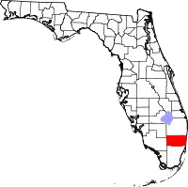

FORT LAUDERDALE AND BROWARD COUNTY
ECONOMIC OUTLOOK OVERVIEW

WELCOME TO GREATER FORT LAUDERDALE, SOUTH FLORIDA
(Gateway to Latin America and the Caribbean)

Long known as an international tourist destination, Greater Fort Lauderdale is now the heart of a robust, economic high-growth region. As the geographic centre of the Miami-Fort Lauderdale-West Palm Beach Metropolitan Statistical Area (MSA), Greater Fort Lauderdale has everything you need to succeed - diversified workforce; large market with disposable income; easy access to national/international markets; world class educational options; business friendly government; and outstanding lifestyle. In addition, any area can be designated as a foreign trade zone (FTZ) offering tax, tariff and import advantages.

Fort Lauderdale | South East Florida (MSA)
Population 178,752 | Population 6.8 million - 8th largest in the USA
Retail/Restaurant Sales $ 6.1 billion | Retail/Restaurant Sales $ 106.3 billion
Civilian Workforce 84,369 - 62.5 % white collar,  6.5 % blue collar, 21.1 % service | Civilian Workforce 3.0 million - 61.1 % white collar,  17.3% blue collar, 21.7 % service
Education - 42.3 % college degree,  18.9 % some college | Education - 37.7 % college degree,  8.7 % some college
All America City, National Civic League | Best Places to Start a Small Business, Biz Journals
Most Diverse City in Florida, Wallet hub | Future Top Cities in US, FDI Magazine
Top 10 Greenest Mid-Sized Cities, MyLife.com | 2nd Best Place to Start a Business,  Kauffman Foundation
Top 10 Best Downtowns in the USA, Livability.com | 3rd Least-Costly MSA to do business, KPMG
Top 10 Most Exciting Mid-Sized Cities in America | Home to more than 6,000 High Tech firms, Brookings Institute
Top 10 US Cities for Small Business, Biz2Credit.com | Best Places for Global Trade, Global Trade Magazine
Top 10 Best Cities for Millennial Job Seekers  in Florida | BCPS High Schools Among America’s Best, Newsweek
Top 50 US “Tech Talent” Markets, CBRE | BEST Hottest Start-Up Hub in US, Kauffman Foundation

KEY INDUSTRIES

There are huge opportunities for British companies to sell consumer products. Broward County has access to 6.8 million people and a diversified multicultural population with an affinity for European and International products.

MARINE
Known as the “International Marine Hub, “Greater Fort Lauderdale’s marine industry leads the State. Fort Lauderdale is the home of the famous Annual Ft Lauderdale International Boat Show and the marine industry encompasses world-class shipyards, manufacturing, wholesale/retail products, brokers, dockage, and every conceivable type of marine service.
The marine industry has an economic impact of $ 8.8 billion in Broward County, generating more than 110,000 jobs. Florida has Sales/Use Tax exemptions that are specific to the Marine Industry.

AVIATION & AEROSPACE
Why are so many aviation & aerospace companies locating in Greater Fort Lauderdale?
- Florida ranked 1st for aerospace companies, PricewaterhouseCoopers
- Florida ranked 1st in the nation for aerospace manufacturing
- Florida ranked 2nd in USA for the number of aviation/aerospace companies
- Florida has Sales/Use Tax exemptions specific to the Aviation Industry
- Greater Fort Lauderdale’s aerospace roots is a legacy of its history as an aviation hub
- Embraer and Heiko are headquartered in Broward County

CONSUMER PRODUCTS
There is tremendous perceived value of British brands and goods across the Americas, and SMEs from the world over are moving to these dynamic markets. South Florida’s vibrant multicultural community promises great demand for innovative, quality British merchandise. Not only the home to a vibrant Latin American community, South Florida acts as a shopping destination and showcase for millions of Americans that regularly come to South Florida every year.

FOOD, DRINK AND HOSPITALITY
Greater Fort Lauderdale has over 4,100 restaurants, 63 golf courses, 12 shopping malls,
16 museums, 132 nightclubs, and 100 Marinas - hosted 32.5 million visitors who spent
$ 7.6 billion in 2017. Embraced by the Atlantic Ocean, Fort Lauderdale has more than seven miles of beaches and more than 165 miles of inland waterways. Fort Lauderdale has 566 hotel / motel properties with 35,755 rooms and over 11.7 million square feet of shipping and
dining venues.

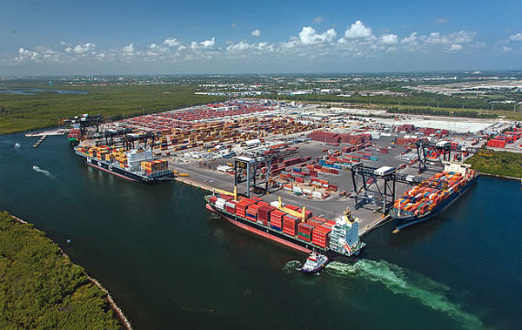
TECHNOLOGY

Why are so many technology companies locating in Greater Fort Lauderdale?

Florida is ranked 3rd in the USA for high-tech companies and exporting of high-tech products
Florida ranked 4th in the USA for technology jobs, Tech America
Ft. Lauderdale among Top 25 US High-Tech Cities, Business Week
Ft. Lauderdale among Top 50 US “Tech Talent Markets, CBRE
Ft. Lauderdale among most wired broadband areas in the USA, Forbes
Home to more than 6,000 high technology firms, Brookings Institute
Headquarters for Microsoft Latin America, Citrix and Magic Leap

GLOBAL LOGISTICS

Global Trade magazine named the City of Fort Lauderdale as one of the best cities for Global Trade - Fort Lauderdale has the facilities and workforce to support global logistics.

Port of Everglades:

Four miles from downtown Fort Lauderdale
#1 in Florida for exports: worldwide trade of $ 24.5 billion
#1 Foreign Trade Zone for Exports - # 18 in the USA

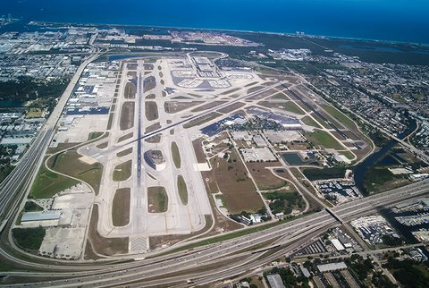

Fort Lauderdale-Hollywood International Airport (FLL):

FLL, four miles from downtown Fort Lauderdale, is ranked 21st in the USA and 7th on the US Airport Affordability Index.

FLL has over 740 flights a day and non- stop service to more than 100 destinations.

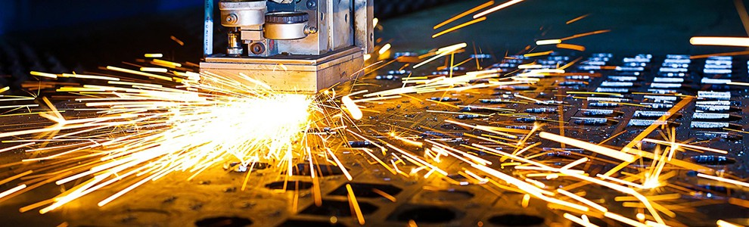
LIFE SCIENCES

Home to approximately 1,500 bioscience businesses and institutions that employ more than 26,000 people. Greater Fort Lauderdale provides a stimulating and supportive business environment for success in the life sciences industry - medical devices, biomedical, pharmaceutical, clinical research, manufacturing and distribution. The region’s academic institutions and research parks have joined together to form Life Sciences South Florida (LifeSciencesSF.org).

MANUFACTURING

Florida ranks in the top 10 for manufacturing and is home to more than 18,600 manufacturing companies with +321,000 employees and accounts for 72,000 jobs in the Miami and

Fort Lauderdale MSA.

Comparative Costs for Manufacturing Companies in Florida versus Other Markets

 | Florida | Alabama | Georgia | Illinois | N.  Carolina | S.  Carolina | Texas
Personal Income Tax (Highest Rate) | None | 5.00 % | 6.00 % | 3.75 % | 5.80 % | 7.00 % | None
State Tax Climate Rank | 4 | 28 | 36 | 31 | 16 | 37 | 10
Manufacturing Average Wage | $54,086 | $50,962 | $53,980 | $54,555 | $53,268 | $68,868 | $70,580

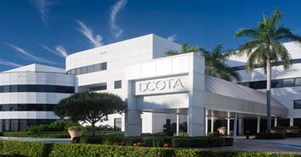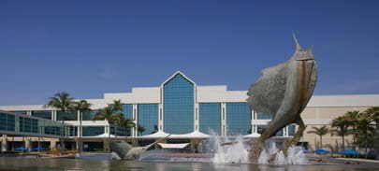

Mission Itinerary * subject to change
Florida International Trade and Cultural Expo (FITCE) 2021 Preliminary Agenda
Arrival of British Delegates| Monday, 15th November 2021 |MEET AND GREET AT HOTEL (TBA)
Setup Day| Tuesday, 16th November 2021 |INTERNATIONAL DELEGATES

9:00AM – 5:00PM | Sponsor & Exhibitor Registration and World Expo Setup

Day 1| Wednesday, 17th November 2021|LEARN

8:00AM – 9:50AM | Registration & Opening Ceremony Breakfast –World Expo Marketplace Opens!
10:00AM – 10:45AM | How to Bring Your Business to the United States of America
11:00AM – 11:45AM | 11 Steps to Exporting - "A Roadmap to Your Exporting Success!"
12:00PM – 1:00PM | Buyers & Sellers Networking Lunch @ World Expo Marketplace
1:00PM – 2:15PM | World Leaders and Former Presidents Panel: Opening Horizons to New Market Opportunities, *"Passport to Prizes" #1
2:30PM – 3:15PM | An international panel of governments, consulates, trade commissioners, binational chambers & country experts discussing their top export and import opportunities and how to do business with their country.
3:30PM – 4:00PM | Networking Coffee/Tea Break
4:00PM – 5:00PM | Doing Business with the World! – THE CARIBBEAN
5:00PM – 7:00PM | Presidential Opening Network Reception Hors d'oeuvres & Cash Bar.  (Hosted by the Renaissance Evolution & Sister Cities International‐ $ cost involved)

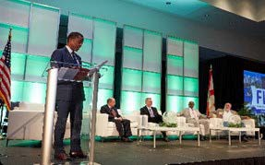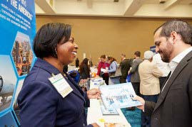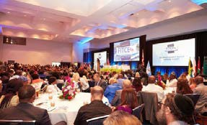

Mission Itinerary * subject to change
Day 2| Thursday, 18th November 2021 |DOING BUSINESS WITH THE WORLD

8:00AM – 9:50AM | Registration & Breakfast –World Expo Marketplace Opens!
10:00AM – 10:45AM | Doing Business with the World! –EUROPE
11:00AM – 11:45AM | Doing Business with the World! –AFRICA
12:00PM – 12:25PM | Doing Business with the World! –ASIA & THE MIDDLE EAST
12:30PM – 1:00PM | Buyers and Sellers Networking I Lunch@ World Expo Marketplace
1:00PM – 1:45PM | International Trade Leaders in Technology  *"Passport to Prizes" #2
2:00PM – 2:45PM | How to Import into the United States of America
3:00PM – 3:40PM | American and International Buyers Panel: How to Sell to Large Organizations
3:40PM – 4:00PM | Meet & Greet Session with the Buyers
4:00PM – 5:00PM | Speed Matchmaking with Country Representatives & Trade Resources  Opportunity for local businesses to meet one-on-one with country representatives. Meetings last fifteen (15) minutes before you rotate to the next country. Meet with numerous participating countries in one afternoon!
5:00PM – 7:00PM | Closing Cocktail Reception & Cultural Exchange Ecuador! (Hosted by the Sustainable Fashion Tech Week). Hors d'oeuvres & Cash Bar  (partner event ‐ $$ cost involved)

Day 3| Friday 19th November 2021 |OTHER EVENTS/FREE TIME FOR MEETINGS

AM: | Tour of The World Trade Center, Fort Lauderdale, Florida

Day 4| Saturday 20th November 2021 |GOODBYE BREAKFAST

Take delegation to Ft. Lauderdale – Hollywood International Airport
*EARLY ARRIVAL is Your PASSPORT to PRIZES!
Join the fun at FITCE and play Passport to Prizes! All attendees arriving at registration by 8AM are eligible to enter to win prizes. To play, arrive at the Registration area before 8AM, complete your registration and drop your business card in the prize drum to be entered to win a prize in the World Expo Marketplace. Must be present to win. Winners will be announced.
Mission Cost
Registration Deadline:
19th October 2021
Package includes the following:

- Admission to mission events
- Airport transfers in country when travelling on official mission flights
- Ground transportation to all mission events.

*Delegate package does not include any one-on-one appointments.
₤150 per person
Option 1: Delegate*
HOTEL:
OFFICIAL CONFERENCE HOTEL: Hilton Fort Lauderdale Marina

Conference room rates starting at $179/night (taxes not included) are available only until October 7, 2021 (limited availability). To book this special rate, please visit the Reservation Portal​ and select 'ATTENDEE' from the drop-down. Remember: BOOK EARLY! (Limited Availability)
*All F&B prices and services provided by the hotel are subject to a 23% service charge and 6% sales tax. Prices are subject to change.
You can also get further assistance by calling Travel to do Good at 01-954-649-2922.
Package includes the following:
- One-on-one appointments with pre-screened buyers/distributors
- Admission to mission events
- Airport transfers in country when travelling on official mission flights
- Ground transportation to all mission events.

*Initial assessment is done to determine how many meetings can be organised
₤150 per person plus
₤500 per appointment
Option 2: Matchmaking Package * (Discounted for FITCE 2021)

ESTIMATED TRAVEL COSTS:

FLIGHTS: (estimated costs)
15th November LHR - MIAMI (Inbound)
20th November MIAMI - LHR (Outbound)

British Airways Basic Economy return fare. £614.00 (tax included)

Delta operated by Virgin Atlantic return fare. £1070.00 (tax included)

* fares are subject to change at time of booking. Based on availability by the airline.

British Department for International Trade (DIT)
Delegates will also have the opportunity to take advantage of the unparalleled trade facilitation services provided by the British Department of Trade and Industry (DIT) both in the UK and Miami, Florida.
The DIT offers a variety of products and services designed to facilitate British exports and foreign direct investment opportunities.
Please refer to https://www.gov.uk/government/organisations/department-for- international-trade for details of your local DIT offices. Details for all DIT services can be found at https://www.great.gov.uk/uk/
The delegation will be limited to British manufacturers, distributors and service companies.
Selection of these firms will be on a first come first-served basis.

Financial support may be available towards your travel costs – please speak to your local Chamber of Commerce or Department for International Trade (DIT) office to explore what is available from them, as this varies from region to region.
Disclaimer: Made in Britain Trade Centres, the DIT and the Expo organizers will NOT be legally responsible in any way for any losses or damage of any nature (pecuniary or otherwise) that might arise from an introduction to a potential buyer or distributor or for the arrangement of hotel and air flight bookings.

Mission Registration:
Registration can be done online on the website: www.tradewithbritain.com

Payment details for British Trade Mission:

Made in Britain Trade Centres Limited HSBC BANK
- Commercial Way WOKING.
Surrey. GU21 6EZ

Sort Code: 40 47 08
Account No. 52483327

Enquiries: Please contact

Christopher George

Chairman/CEO
Made in Britain Trade Centres Ltd
Phone: +44 (0)7964 321 517 (UK)
+1 954 330 4930 (USA)
Email: chris@tradewithbritain.com
Website: www.tradewithbritain.com

Paola Isaac Baraya, MSc. (FITCE Event Director)
Economic Development-International Trade
Broward County Office of Economic and Small Business Development Florida USA

Phone: +1 954-357-7894 (USA)

Email: PISAAC@broward.org

Cancellations
Cancellations must be made in writing to be fully refundable by
23rd October 2021 to:

Christopher George: chris@tradewithbritain.com

Cancellations after that date are non-refundable

